Mass Push of incomplete forms
We will be moving anyone who is not in the 1:1 meeting step to the 1:1 meeting step
2 different population we will need to move the forms for :
The Service Center Population- which we will move all the forms from calibration step to 1:1 meeting

Service center refers to our Team members who work in the distribution center specifically the team addition Team member (another set of users that work in DC , more likely supervisors. But they are not floor workers or Packaging people. These Service Center people have their own Service Center performance forms)

General Population - majority of the pop other than Service Center population

To Route the Performance Form template:
Admin Center >Route form >upload CSV file

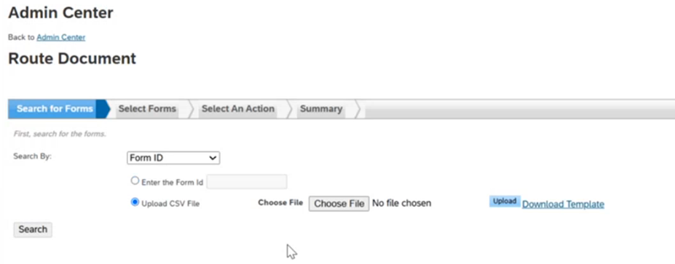

Download Template
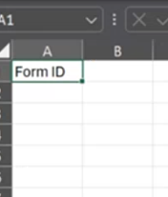
We will get the form iD from a report
Report Center > all reports >2024 reports >2024 Performance reports > 2024 Performance Module (Admin)
Document ID in the Report (1st Column) is the Form Id.
Export the report in Excel
